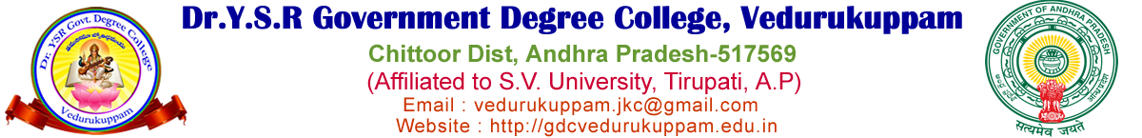
ALUMNI
The co-ordinator: Dr. V. Nageswara Rao
MA, M.Ed, MA, UGC NET (Eng), UGC NET (Edu), AP SET (Eng), AP SET (Edu), PhD.
Lecturer in English
College alumni play a vital role in the growth and development of an educational institution. Alumni are the former students who have completed their education and moved on to various professions and walks of life. Even after leaving the campus, they remain an integral part of the college community, contributing to its progress in many meaningful ways.
One of the most important roles of alumni is to maintain a strong connection with their alma mater. They often visit the college to share their experiences, interact with current students, and guide them in making career choices. Their real-life experiences provide valuable insights that go beyond textbooks and classrooms. Such interactions motivate students to work hard and achieve their goals.
Alumni also contribute to the development of the college by providing financial support and resources. Many successful alumni donate funds for the improvement of infrastructure, scholarships, libraries, and laboratories. Their generosity helps the institution offer better facilities and opportunities to present and future students.
In addition to financial support, alumni actively participate in various college activities. They are often invited as chief guests, speakers, or mentors during seminars, workshops, and cultural events. Their involvement strengthens the relationship between the past and present students and builds a sense of unity and pride in the institution.
Another significant contribution of alumni is their support in organizing social service activities such as NSS camps, blood donation drives, and health awareness programs. They work alongside students and faculty, demonstrating a strong sense of social responsibility. Their participation encourages students to engage in community service and develop leadership qualities.
Alumni associations also play a crucial role in networking and career development. They create platforms where former students can connect, share opportunities, and support each other professionally. This network benefits both alumni and current students by opening doors to internships, jobs, and collaborations.
Moreover, alumni serve as ambassadors of the college. Their achievements and success in different fields bring recognition and reputation to the institution. A strong alumni base reflects the quality of education and values imparted by the college.
In conclusion, college alumni are a valuable asset to any institution. Their contributions in the form of guidance, financial support, participation, and social service help in shaping the future of the college and its students. Maintaining a strong bond with alumni is essential for the overall growth and success of the institution.

Alumni Support to NSS Camp at Perumallapalli from Dec 17th to 23rd, 2025.
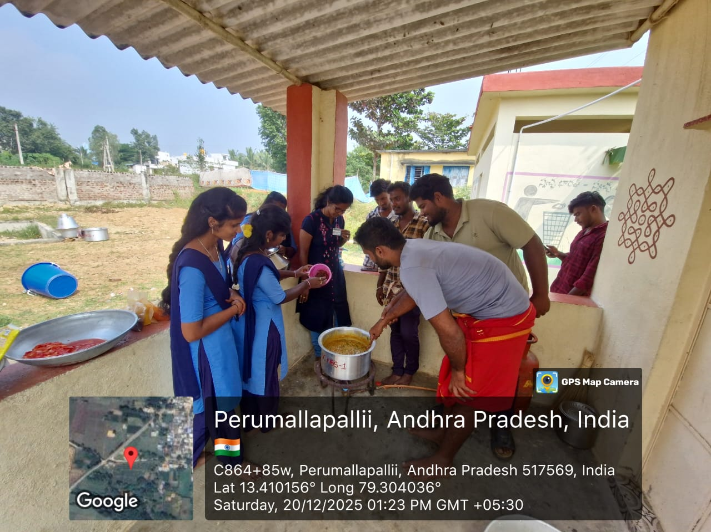
The students from ALUMNI preparing food for NSS volunteers
The spirit of service and social responsibility lies at the heart of the National Service Scheme (NSS). An inspiring example of this spirit was witnessed during the NSS camp conducted by our college in Perumallapalli village, located in Vedurukuppam mandal of Chittoor district. What made this camp truly special was the active participation and generous support extended by the old students (alumni) of the college.
The alumni, who once walked the same corridors and participated in similar service activities, returned with a deep sense of gratitude and responsibility. Their presence at the camp not only strengthened the morale of the NSS volunteers but also created a bridge between past and present students. They demonstrated that the values learned during college life—especially service to society—remain relevant throughout one’s life.
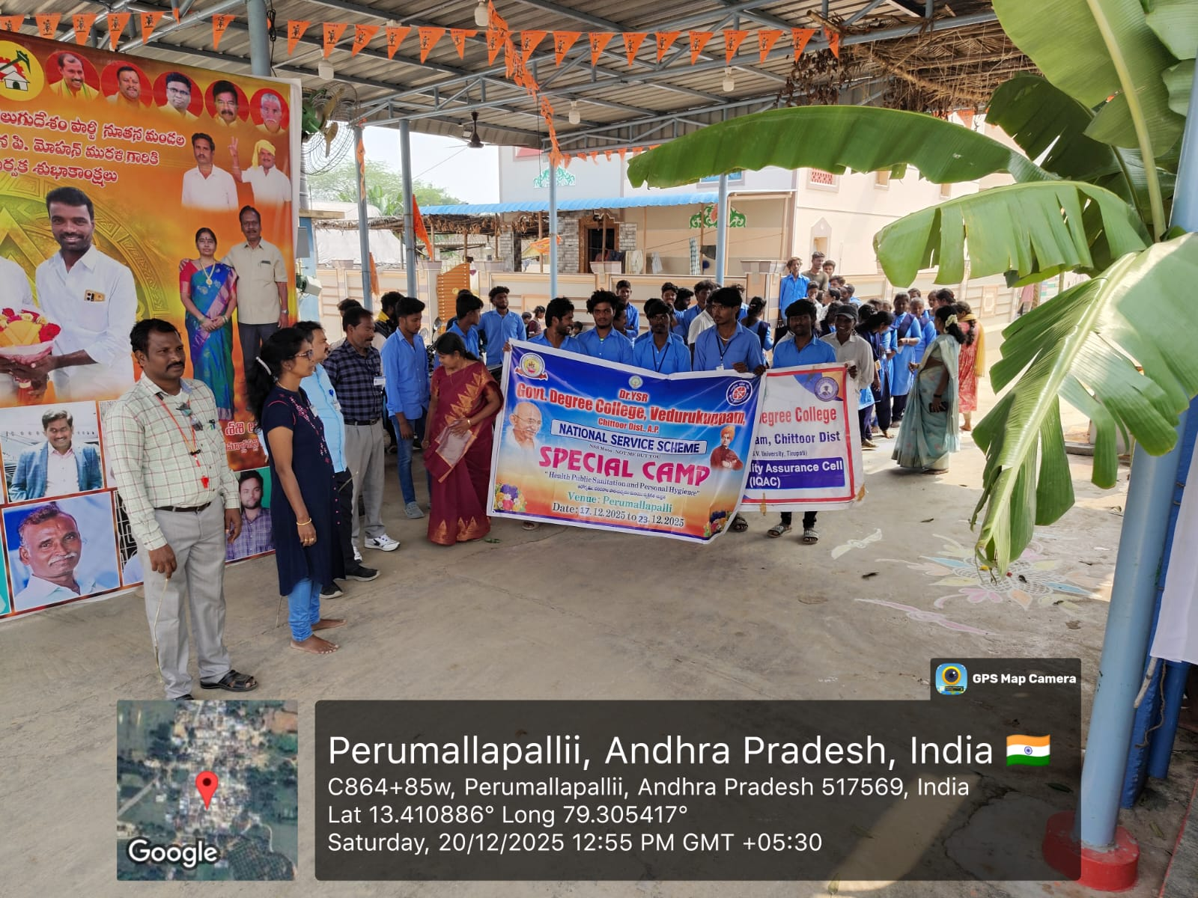
The alumni- part of the camp at the rally
During the NSS camp, the alumni contributed in multiple ways. Some provided financial assistance to support the organization of activities such as medical camps, cleanliness drives, and educational awareness programs. Others actively participated alongside the volunteers, engaging in village development works such as sanitation, plantation, and public health awareness. Their willingness to work hand-in-hand with the students inspired a strong sense of unity and dedication.
One of the most valuable contributions of the alumni was their guidance and motivation. They shared their life experiences, career journeys, and the role NSS played in shaping their personalities. Their words encouraged the volunteers to develop leadership qualities, social awareness, and a sense of responsibility towards the community. These interactions helped students understand the long-term impact of their participation in NSS.
The villagers of Perumallapalli also benefited greatly from the alumni’s involvement. The combined efforts of alumni and NSS volunteers brought noticeable improvements in the village environment. Awareness programs on health, hygiene, and education were conducted effectively, leaving a lasting impression on the local community.
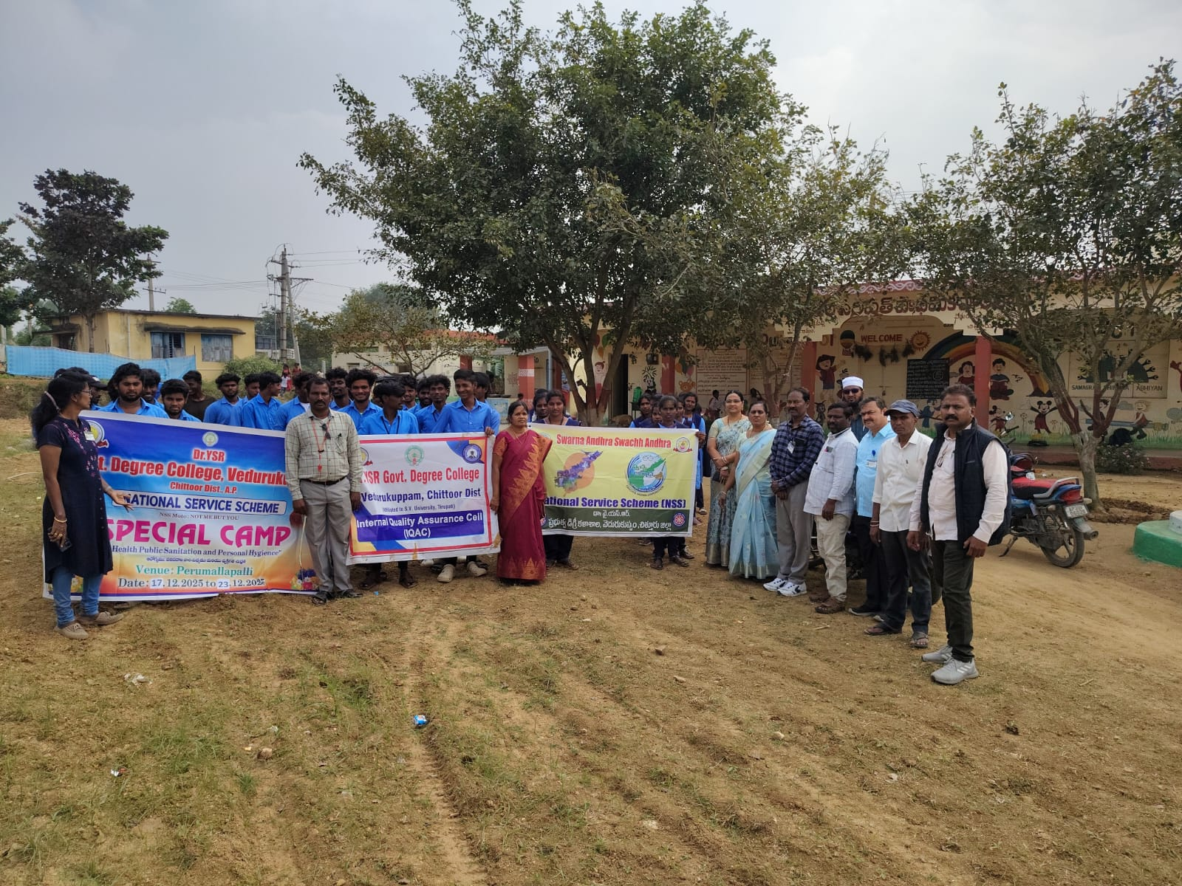
Start of the rally
Moreover, the alumni’s participation strengthened the relationship between the college and its former students. It highlighted the importance of staying connected and contributing back to the institution and society. Their involvement set a positive example for current students, encouraging them to remain engaged with their alma mater even after completing their education.
In conclusion, the active participation of old students in the NSS camp at Perumallapalli village was a remarkable demonstration of commitment, gratitude, and social responsibility. Their support not only enhanced the success of the camp but also inspired the present generation to uphold the values of service and humanity. Such initiatives remind us that education is not just about academic achievement, but also about contributing meaningfully to society.
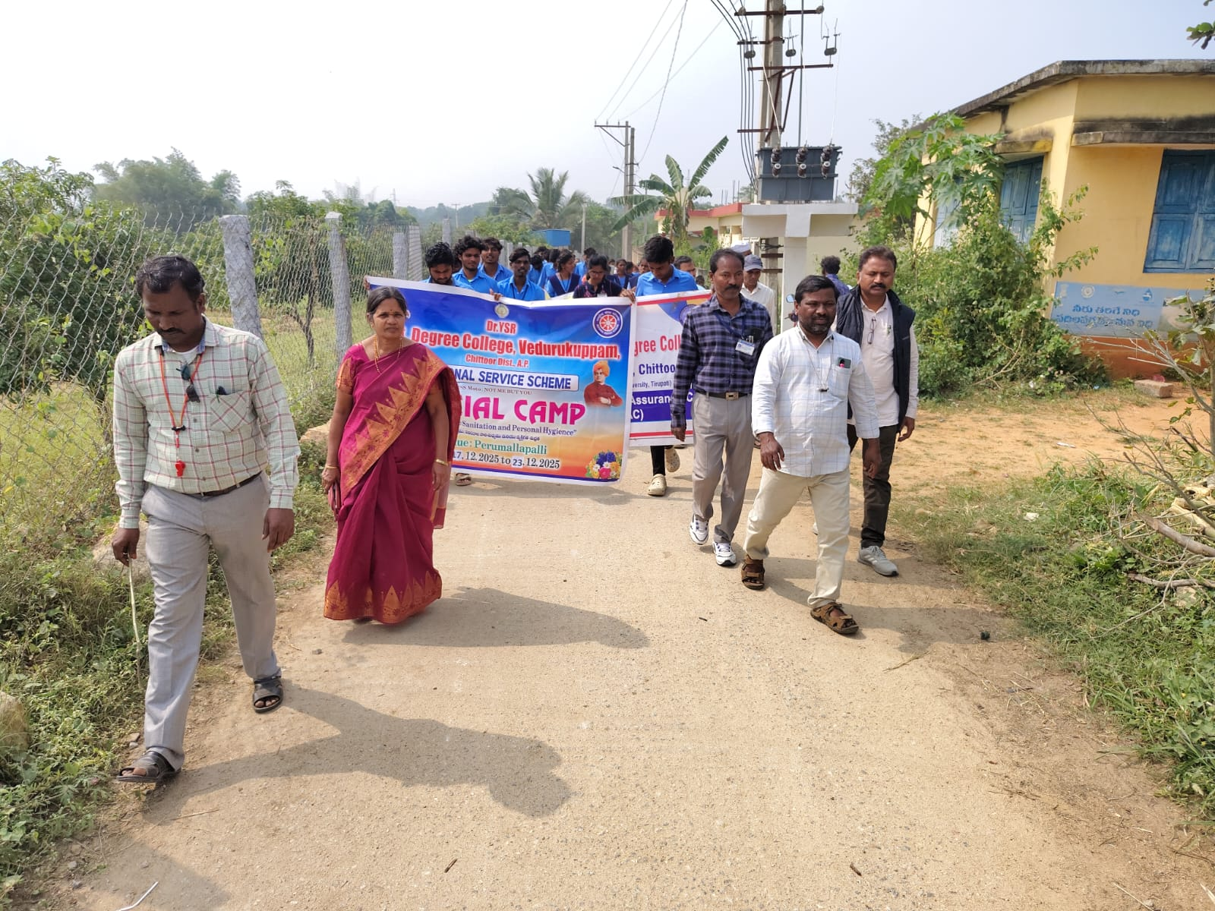
Rally-awareness programme
The alumni played a vital role in ensuring the smooth functioning of the camp. One of their key contributions was arranging and serving good and nutritious food for all the NSS volunteers and participants. Their efforts ensured that everyone remained energetic and motivated throughout the camp. They personally participated in cooking, organizing, and serving meals, showing humility and a true spirit of service.
In addition to food arrangements, the alumni actively engaged in various service programs conducted during the camp. They joined the volunteers in activities such as village cleaning, awareness campaigns, and community development works. Their participation alongside the students created a sense of unity and teamwork, making the programs more effective and impactful.
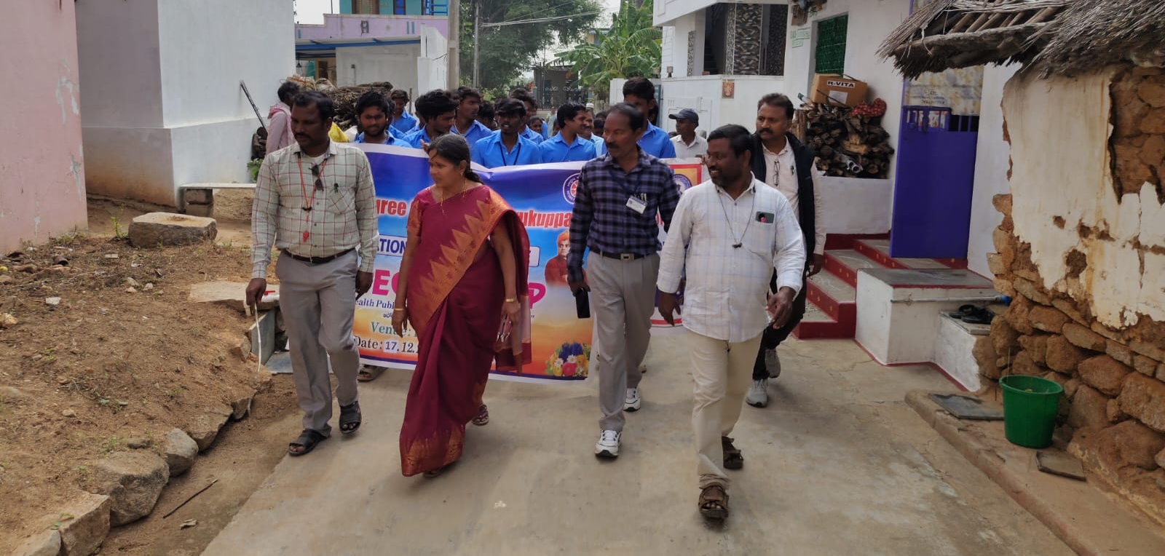
Rally
The alumni also took part in the health camp organized for the villagers. They assisted medical professionals in coordinating the camp, managing the crowd, and helping villagers access medical services. Their involvement made the health camp successful and beneficial to the local people, especially those who lacked access to proper healthcare facilities.
Their presence and contribution served as a great source of inspiration for the current students. By working selflessly and dedicating their time and resources, the alumni demonstrated the true values of NSS—“Not Me But You.” They showed that the lessons learned during college life continue to guide them even after years.
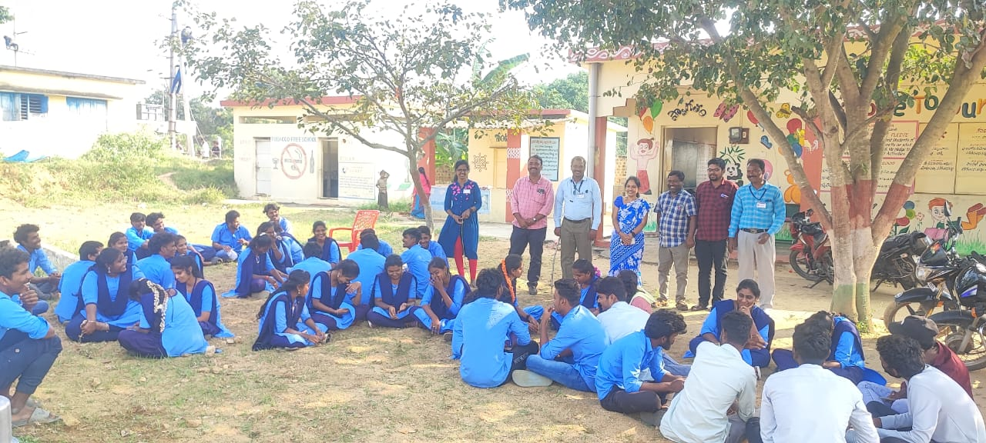
Conducted quiz programme helped by the Alumni
Moreover, the villagers of Perumallapalli appreciated the combined efforts of the alumni and NSS volunteers. The camp brought positive changes in the village and strengthened the bond between the college and the community.
In conclusion, the participation of old students in the NSS camp was highly commendable. Their support in serving good food, participating in service programs, and contributing to the health camp made the event a grand success. Their actions reflected dedication, compassion, and a strong sense of social responsibility, leaving a lasting impression on both the students and the villagers.

